Design: Manual Text Reporting

Overview

Current processing
Information like begin summary, summary data, end summary and settlement prices are currently being transferred to OPRA and other systems.
Currently, TextMessageConsumerHome (consumer) is configured in Hybrid Trade Server. Our task is to configure it in CoppAdapter.

New requirement:
The Text Reporting allows the user to send three lines of text (any specific number of characters??? – can be asked as a question, nothing mentioned in the HHD) to OPRA. This is used for communication with OPRA for changing market conditions, settlement prices, interest rate product underlying updates and manual index updates. Write a consumer which will connect to event channel and consume text message and will pass on this text to Copp Global Adapter.
Currently, TextMessageConsumerHome (consumer) is configured in Hybrid Trade Server. Configure TextMessageConsumerHome in CoppGlobalAdapter. Also, make sure that consumer listens to only the messages destined for it. To make sure that, add a filter to the event channel which will filter out unwanted messages. The messages should be transferred in a specified format to COPP.
The text message should be logged with timestamp. If the message transmission fails it should be again sent back to OPRA till the time it is sent successfully.

Implementation

OpraSummaryService.idl
The changes to the IDL are in-place.
IDL name – OpraService.idl
Module name - externalIntegrationServices
Interface name - OpraSummaryService – An operation called acceptTextMessage(String id, String sessionName, String message, char sessionIndicator) is to be added in IDL.

constants.idl
IDL Name – constants.idl
Module name – constants
Interface name – ManualTextMessageConstants – Add this interface. Add a string constant as MANUAL_TEXT_MESSAGE_USER.

3. TextMessagingConsumerManualTextConsumer
This class will implement TextMessageConsumer.
This will be the consumer of the text message intended for OPRA.
- Class will have acceptTextMessageForUser (String userId, MessageTransportStruct messageTransportStruct) method that calls the sendTextMessage method of CoppGlobalBridgeHomeImpl.
- Get object of CoppGlobalBridgeHomeImpl as follows-
Write a method as getCoppGlobalHome(). Inside the method create an object of HomeFactory. Call findHome(CoppGlobalBridgeHome.HOME_NAME) on homeFactory object. Return the fetched home to the caller.
- Class will have empty implementation for accepttextMessageForProductClass(String userId, MessageTransportStruct messageTransportStruct).
4. CoppGlobalBridgeHomeImpl
Enhancements to existing class are required as mentioned below.
  - In the initialize() method create object of TextMessagingConsumerManualTextConsumer. Pass it the current instance of CoppGlobalBridgeHomeImpl.
  - In the initialize() method get the object of TextMessageConsumerHome. Invoke addConsumer method on it passing the object of TextMessagingConsumerManualTextConsumer and channel key as parameters.
  - At the time of ChannelKey object creation, pass a channelType (ChannelType.TEXT_MESSAGE_BY_USER) and a User ID String that is read from ManualTextMessageConstants interface generated from IDL interface ManualTextMessageConstants inside constants.idl.

5. TextMessageConsumerImpl
- Modify createInclusionFilters(ChannelKey key) method. Add one case statement above existing case statement.
- If ChannelType is TEXT_MESSAGE_BY_USER then create a ConsumerFilter object by calling createInclusionFilter method on ConsumerHelper object.
- The filter string that will be used is:
$.acceptTextMessageForUser.userId ==' " + channelKey.key + " ' (where
channelKey.key = OPRA_W_MAIN)

Sequence Diagram
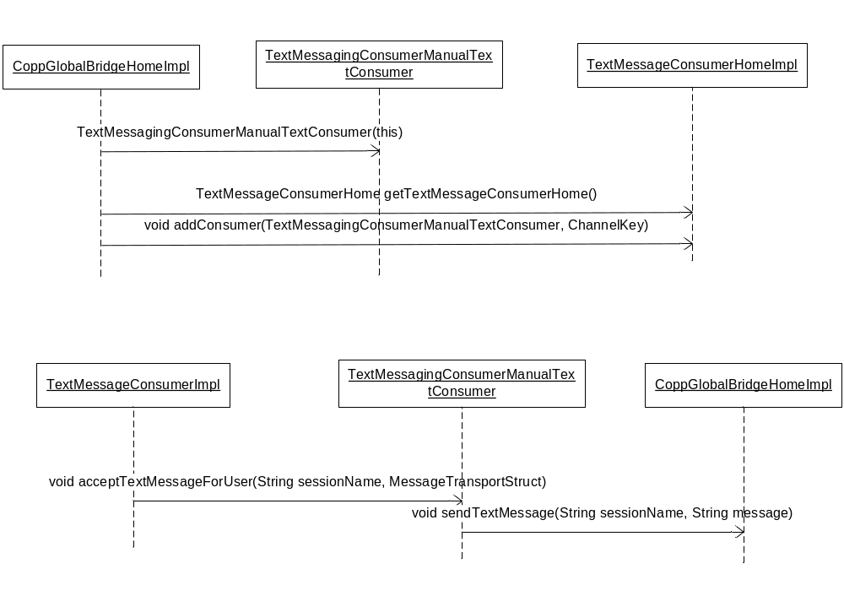

Scripts(2)
None

Database(.5)
None

SetContext(.125)
None

XML/DTD(.5)
CoppGlobalAdapter.xml
- Add a BOHome tag with following attributes in BOContainer ‘adapter’-
<BOHome name="TextMessageConsumerHome">
<BOHomeProperties>
<homeImpl>com.cboe.server.events.TextMessageConsumerHomeImpl</homeImpl>
<managedResourceName>TextMessageConsumerHomeImpl</managedResourceName>
</BOHomeProperties>
</BOHome>

CoppGlobalBridgeHome.xml
- Add routing proxy for W_MAIN session. RemoteServiceRoutenameSessions will have additional value ‘OptionsOnEquity’.
<remoteServiceRoutenameSessions>OptionsOnFutures,OptionsOnEquity</remoteServiceRoutenameSessions>
</CoppGlobalBridgeHomeImplProperties>
<remoteServiceRoutenameConfiguration name = "OptionsOnEquity">
<remoteServiceRoutenameConfigurationProperties>
<sessionName>W_MAIN</sessionName>
<productTypes>7</productTypes>
<userId>OPRA_W_MAIN </userId>
</remoteServiceRoutenameConfigurationProperties>
</remoteServiceRoutenameConfiguration>

Homes/Services(2)
None

ImplPlan(.5)
Send text message from trader GUI as follows:
- Open trader GUI. In settings select ‘Network Test’ as login mode. Write ‘CCC’ in text box next
to ‘unlock’. CAS location should be ‘dev17cas’ and port 8003.
- Click ‘SUBMIT’ and then ‘CONFIRM’.
- UserId / Password: You can use the pairs from X01 / X01 to X20 / X20.
- Once logged in, click on ‘Start’ button and select ‘Message Center’ from drop down. Then create a window for ‘OPRA’.
- In the text area write a text message. Ex: SAMPLE TEXT MESSAGE.

This message appears in CoppGlobalAdapter.log file.

PerformanceTestingProcedure(1)
No overhead to system.

TestingProcedure(1)
None

OperatorProcedure(.5)
None

Fallback/Failover
None

GUI Design
Trader GUI needs to add new Screen for allowing user to add Text Message.

Appendix:
